# COMPUTER VISION

**EXERCISE 0: Introduction to Matlab**

Concepts: Image loading, saving, and conversion.

1. Simple image manipulation:
   1. Load the color image **lily.tif**,
   2. convert it to grayscale,
   3. show its histogram and
   4. save it as **lily_gris.tif**.
2. Implement an *script* file showing in the screen, in a subplot:
   1. The initial **lily_gris.tif** image.
   2. Binary image from thresholding it (threshold=100).
   3. Image with half resolution.
   4. Middle part of the image with half the size.

**Results**

1.

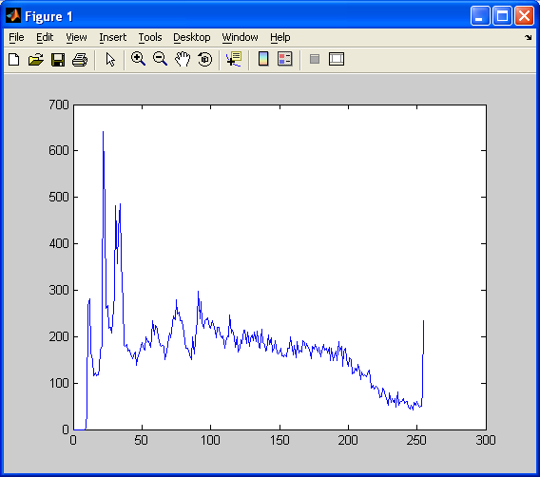

2.

